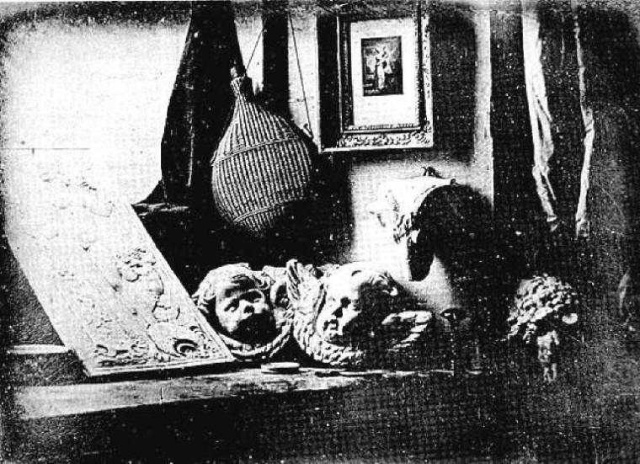
DAGUERRE, Louis Jacques Mande
b. 18 November 1787; d. 10 July 1851
Daguerre (pronounced Dagair) was perhaps the most famous of several people who invented photography.
He began work as an apprentice architect, and at the age of sixteen was an assistant stage designer in a Paris theatre, his elaborate stage designs winning him considerable acclaim. He had an astonishing ingenuity in the handling of light and lighting effects, and he supplied the scenic and lighting effects for a number of operas in theatres in Paris.
He regularly used a camera obscura as an aid to painting in perspective, and this had led him to seek to freeze the image. In 1826 he learned of the work of Nicephore Niépce, and on 4 January 1829 signed up a partnership with him.
The partnership was a short one, Niépce dying in 1833, but Daguerre continued to experiment. He made an important discovery by accident. In 1835, so the story goes, he put an exposed plate in his chemical cupboard, and some days later found, to his surprise, that the latent image had developed. Daguerre eventually concluded that this was due to the presence of mercury vapour from a broken thermometer. This important discovery that a latent image could be developed made it possible to reduce the exposure time from some eight hours to thirty minutes. [NOTE: Latent means that the object is there, but it is NOT visible.]
Though he now knew how to produce an image, it was not until 1837 that he was able to fix them. This new process he called a Daguerreotype.
From the day the announcement was made of this new discovery, the process came to be used widely.
The Literary Gazette for 7 January 1839 read:
"Paris, 6th January 1839.
We have much pleasure in announcing an important discovery made by M. Daguerre, the celebrated painter of the Diorama... if borne out, promises to make a revolution in the arts of design.
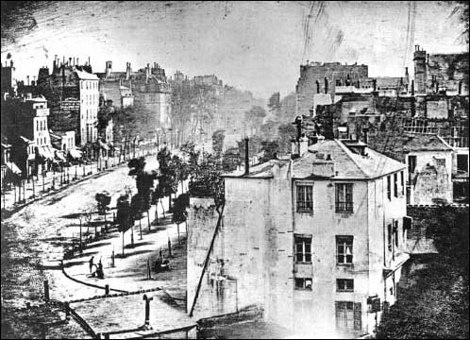
M. Daguerre has discovered a method to fix the images which are represented at the back of a camera obscura; so that these images are not the temporary reflection of the object, but their fixed and durable impress, which may be removed from the presence of those objects like a picture or an engraving."
An article in La Gazette de France, of the same date, also showed one of the limitations of the process:
"Nature in motion cannot reproduce itself, or at least can do so only with great difficulty, by the technique in question. In one of the boulevard views.... it happened that all which moved or walked did not appear in the drawing...."

The early daguerreotypes had several drawbacks:
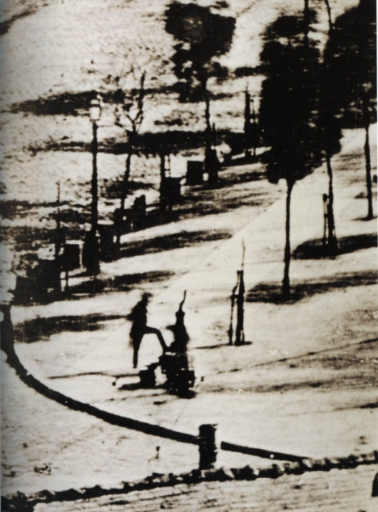
the length of the exposure necessary all but ruled out portraiture.
the image was laterally reversed it was very fragile.
perhaps most limiting of all, it was a "once only" system; what was needed was a means whereby copies of a photograph might easily be made.
Taken in 1839, this picture of a boulevard gives the impression of empty streets, because with long exposures moving objects would not register.
However, there was an exception when a man stopped to have his shoes shined, (see bottom left of the larger picture) and though he and the person shining the shoes remain anonymous, they may have the distinction of being the first people ever to have been photographed.
In 1851 Daguerre died. In a sense this symbolically ended an era, for that very same year a new technique was invented, which was another milestone in photography.
Questions: Answer questions below, and highlight in reading where the answer is found.
- Read the Article. Answer the questions at the end of the reading.
- Underline where answers are found in the article.
- Go to Google Images, search the following word combinations and save 5 Photographs for word combination. Make sure that the Photographs that you save go with the concepts the article is writing about.
A. Camera Obscura
B. Daguerreotype Images
C. Daguerre Photo Boulevard
D. Louis Daguerre
- Create folder for Pictures that you are saving. Put saved pictures in this folder. Call the folder Daguerre.
- Go to Photoshop/File/Automate/Contact sheet 2. Select the folder Daguerre and put row column at 4, by 5. This is so all 20 pictures are on one sheet of paper.
- What did Daguerre use a camera obscura for?

- How did Daguerre discover how to make a latent image visible?

- What was different from the Daguerreotype image?

- What was a limitation to the Daguerreotype process?

- Name the 3 drawbacks to the Daguerreotype process?

- Daguerre’s photo of the Boulevard probably captured what for the first time?

