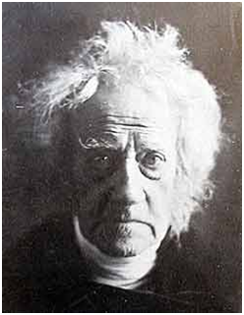BEGINNINGS OF PHOTOGRAPHY
Sir John Herschel

First, the name. We owe the name "Photography" to Sir John Herschel , who first used the term in 1839, the year the photographic process became public. (*1) The word is derived from the Greek words for light and writing.
There are two distinct scientific processes that combine to make photography possible. It is somewhat surprising that photography was not invented earlier than the 1830s, because these processes had been known for quite some time. It was not until the two distinct scientific processes had been put together that photography came into being.

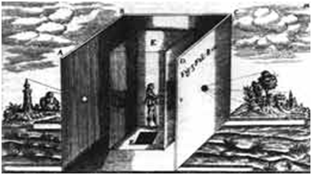The first of these processes was optical. The Camera Obscura (dark room) had been in existence for at least four hundred years. There is a drawing, dated 1519, of a Camera Obscura by Leonardo da Vinci; about this same period its use as an aid to drawing was being advocated.
Camera Obscura
The second process was chemical. For hundreds of years before photography was invented, people had been aware, for example, that some colors are bleached in the sun, but they had made little distinction between heat, air and light.
In the sixteen hundreds Robert Boyle, a founder of the Royal Society, had reported that silver chloride turned dark under exposure, but he appeared to believe that it was caused by exposure to the air, rather than to light.
Angelo Sala, in the early 17th century, noticed that powdered nitrate of silver is blackened by the sun.
In 1727 Johann Heinrich Schulze discovered that certain liquids change color when exposed to light.
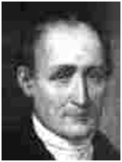At the beginning of the nineteenth century Thomas Wedgwood was conducting experiments; he had successfully captured images, but his silhouettes could not survive, as there was no known method of making the image permanent.
Joseph Nie’pce

The first successful picture was produced in June/July 1827 by Joseph Niépce, using material that hardened on exposure to light. This picture required an exposure of eight hours.
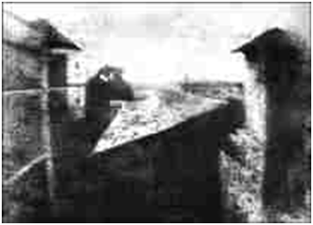
The First Photograph: Roof Pigeon coop.
Questions: Answer questions below, and highlight in reading where the answer is found.
- Read the Article. Answer the questions at the end of the reading.
- Underline where answers are found in the article.
- Go to Google Images, search the following word combinations and save 5 Photographs for word combination. Make sure that the Photographs that you save go with the concepts the article is writing about.
A. Camera Obscura
B. 1st Photograph
C. 1st person in Photograph
D. 1st Photograph ever made
- Create folder for Pictures that you are saving. Put saved pictures in this folder. Call the folder Daguerre.
- Go to Photoshop/File/Automate/Contact sheet 2. Select the folder Daguerre and put row column at 4, by 5. This is so all 20 pictures are on one sheet of paper.

- Who do we owe the name Photography to?

- What are the two Greek words that Photography was derived from?

- Name the two scientific processes that needed to be combined for Photography to be possible?

- Who was Joseph Nie’pce?

