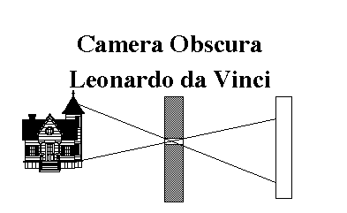
THE BASIC CAMERA PARTS
The principle upon which all camera equipment works is traced back to artist and inventor Leonardo da Vinci who showed that all that was needed to project an image was a small pinhole through which light could pass. The smaller the hole the sharper the image. The basic camera, called a "camera obscura" or pinhole camera, existed in the early 17th Century. It took much longer for science to find a light sensitive material to record the image. It was not until 1826 when Joseph Niepce (pronounced Neep-sea) from France discovered that silver chloride could be used to make bitumen sensitive to light that images began to be formed in a camera.

EVERY camera has 4 basic parts.
This first and main part is called the body. It is a light tight BOX, that holds the film (or, other Light sensitive material) and allows us to carry it around from subject to subject.
The Second part is a Aperture, or hole or opening, which allows light to enter the light tight box. The Aperture is usually located in the lens of most cameras. The aperture is a set of leaf like piece of metal that can change the size of the hole that lets in light.
The Third part is the shutter which in most cameras might be located in the lens (leaf shutter) or it might be located right in front of the film (focal plane shutter). The shutter controls WHEN the light enters the camera and for how long it enters. A good camera will have some way of adjusting the amount of time the shutter is open plus there has to be some type of release for the shutter.
Finally, we have the Fourth part which is a light sensitive material that will record the image. A number of different mediums can be used. Film is the medium of choice for the traditional camera. In a Digital camera it is a CCD, Charged-Coupled Device.
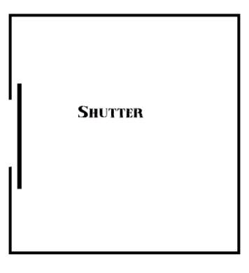
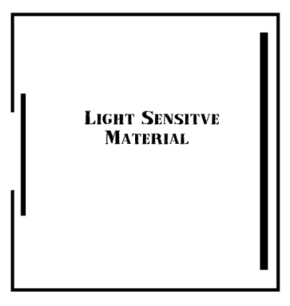

Answer the Question and Underline where the answer is found in the reading:
- Read the Article. Answer the questions at the end of the reading.
- Underline where answers are found in the article.
- Go to Google Images, search the following word combinations and save 3 Photographs for word combination. Make sure that the Photographs that you save go with the concepts the article is writing about.
A. Single Lens Reflex
B. Pinhole
C. Twin Lens Reflex
D. Polaroid
E. Digital Camera
- Create folder for Pictures that you are saving. Put saved pictures in this folder. Call the folder Daguerre.
- Go to Photoshop/File/Automate/Contact sheet 2. Select the folder Daguerre and put row column at 3, by 5. This is so all 20 pictures are on one sheet of paper.

1. What did Leonardo da Vinci say was needed to project an image?

2. What was the first Basic Camera called?

3. What took Science a long time to find?

4. Why does a camera need to be light tight?

5. What is Aperture also referred to as?

6. What kind of shutter does a good camera have?

7. What is the light Sensitive material called in a digital camera?

