The History of 35 mm Film and Cameras
35 mm film is the film gauge most commonly used for chemical still photography and motion pictures. The name of the gauge refers to the width of the photographic film, which consists of strips 1.377 ±0.001 inches (34.98 ±0.03 mm) wide.
The 35 mm width was first used in 1892 by William Dickson and Thomas Edison for movie making, using film stock supplied by George Eastman. The 35 mm width with 4 perforations per frame became accepted as the international standard gauge in 1909, and has remained by far the dominant film gauge for image origination and projection despite challenges from smaller and larger gauges, and from novel formats, because its size allowed for a relatively good tradeoff between the cost of the film stock and the quality of the images captured. The ubiquity of 35 mm movie projectors in commercial movie theaters makes it the only motion picture format, film or video that can be played in almost any cinema in the world.
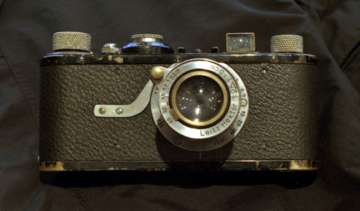
First 35mm Cameras
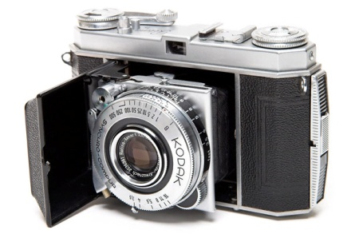
Oskar Barnack, who was in charge of research and development at Leitz, decided to investigate using 35 mm cine film (movie film) for still cameras while attempting to build a compact camera capable of making high-quality enlargements. He built his prototype 35 mm camera (Ur-Leica) around 1913, though further development was delayed for several years by World War I. Leitz test-marketed the design between 1923 and 1924, receiving enough positive feedback that the camera was put into production as the Leica I (for Leitz camera) in 1925. The Leica's immediate popularity spawned a number of competitors, most notably the Contax (introduced in 1932), and cemented the position of 35 mm as the format of choice for high-end compact cameras.
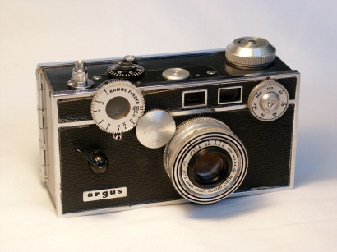
Kodak got into the market with the Retina I in 1934, which introduced the 135 cartridge used in all modern 35 mm cameras. Although the Retina was comparatively inexpensive, 35 mm cameras were still out of reach for most people and roll film remained the format of choice for mass-market cameras. This changed in 1936 with the introduction of the inexpensive Argus A and to an even greater extent in 1939 with the arrival of the immensely popular Argus C3. Although the cheapest cameras still used roll film, 35 mm film had come to dominate the market by the time the C3 was discontinued in 1966.
The fledgling Japanese camera industry began to take off in 1936 with the Canon 35 mm rangefinder, an improved version of the 1933 Kwanon prototype. Japanese cameras would begin to become popular in the West after Korean War veterans and soldiers stationed in Japan brought them back to the United States and elsewhere.
Pre loaded cassettes and Kodak Retina cameras
In the earliest days, the photographer had to load the film into reusable cassettes and, at least for some cameras, cut the film leader. In 1934, Kodak introduced a 135 daylight-loading single-use cassette. This cassette was engineered so that it could be used in both Leica and Zeiss Ikon Contax cameras along with the camera for which it was invented, namely the Kodak Retina camera. The Retina camera and this daylight loading cassette were the invention of Dr. August Nagel. The 35 mm Kodak Retina camera line remained in production until 1969.
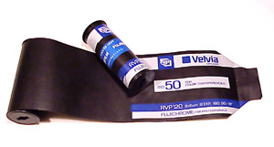
The term 135 (ISO 1007) was introduced by Kodak in 1934 as a designation for cartridge film 35 mm (1.4 in) wide, specifically for still photography. It quickly grew in popularity, surpassing 120 film by the late 1960s to become the most popular photographic film size. Despite competition from formats such as 828, 126, 110, and APS, it remains so today.
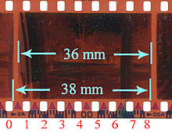
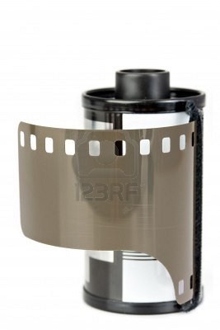
Individual rolls of 135 film are enclosed in single-spool, light-tight, metal cassettes to allow cameras to be loaded in daylight. The film is clipped or taped to a spool and exits via a slot lined with flocking. The end of the film is cut on one side to form a leader.
135 film has been made in several emulsion types and sensitivities (film speeds). Films of lower sensitivity (and better picture quality) and higher sensitivity (for low light) are for more specialist purposes. Image formats on 35 mm film are generally 24 mm wide, between the perforations in the 35 mm wide film. The common "full-frame" image size is 24×36 mm.
The film is available in lengths for varying numbers of exposures. The standard full-length roll has always been 36 exposures (assuming a standard 24×36 frame size). Through about 1980, 20 exposure rolls were the only shorter length with widespread availability. Since then, 20 exposure rolls have been largely discontinued in favor of 24 and 12 exposure rolls.
Canon The company was originally named Kwanon by Goro Yoshida after the Buddhist bodhisattva Guan Yin, known in Japanese as Kannon. In 1934 it produced a prototype for Japan’s first-ever 35 mm camera with a focal plane shutter. In 1947 the company name was changed to Canon.
Answer the following questions and marked where the answers are found in the reading:
1. What market was 35mm film originally made for?

2. Why was 35mm film good for the Motion Picture Industry?

3. Who was Oskar Barnack?

4. How was Kodak’s Retina I important to the 35mm camera industry?

5. Why did Japanese 35mm camera’s become popular?

6. When did 35mm film become more popular than 120mm film?

7. What was the 3 of frames for a full length roll of Film? What is it now?

8. What was the original name of Canon camera company?

