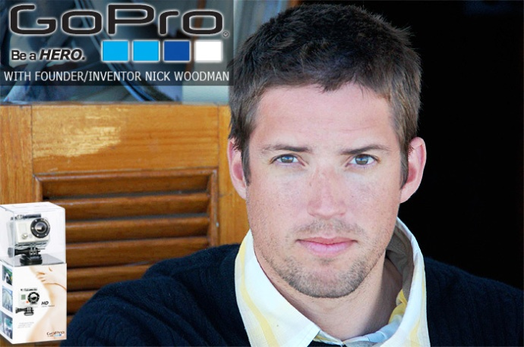
GoPro
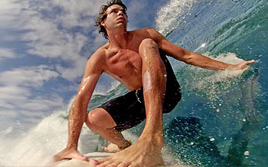
Some people may know when they have an amazing idea for the next best thing, but actually putting that thought into motion can elude them for years, if not altogether. Take Nick Woodman, the founder and inventor of the GoPro Camera, for example. Nick Woodman is the 36-year-old founder and CEO of GoPro, a wearable camera produced by Woodman Labs that can capture footage for athletes as they whiz down a mountain or surf 6-foot waves.
Last week, Foxconn purchased 8.88 percent of Woodman's camera company, GoPro for $200 million. Forbes learned that Woodman is the majority owner. Even if he owns a minimum of 51 percent of the company, that means Woodman is now a billionaire, worth at least $1.15 billion.
I’d had the idea for a wearable camera kicking around in my head since the late ‘90s, but I first really started developing the idea back in 2002 while on surf trip in Australia with a couple of friends. We were living out of a Toyota van, putting in about 5,000 miles surfing the East, South and West Coasts. I was spending most of my time in the water, sharing amazing moments and waves with my friends. I was also shooting photos (this was pre-YouTube!) from the beach, but from that distance my shots weren't doing the surf or my friends justice. Some of the most intense and memorable moments in cranking surf were just that, memories. I'd kill for some GoPro footage of that trip! Ironically, that trip is what fired me up to come home and finally start GoPro to create "the invisible camera," a wearable camera so convenient that you forget you've got it on.
At that time, unless you were a pro surfer, there was no one out in the water to capture a photo of you. That's how I came up with the name GoPro. Most surfers, at some point, wish they could "go pro." My friends and I wanted to go pro just so we could get some footage of us surfing; it was that difficult. So I figured at least a few surfers would be down with the concept of a wearable camera. Thankfully, I was half right.
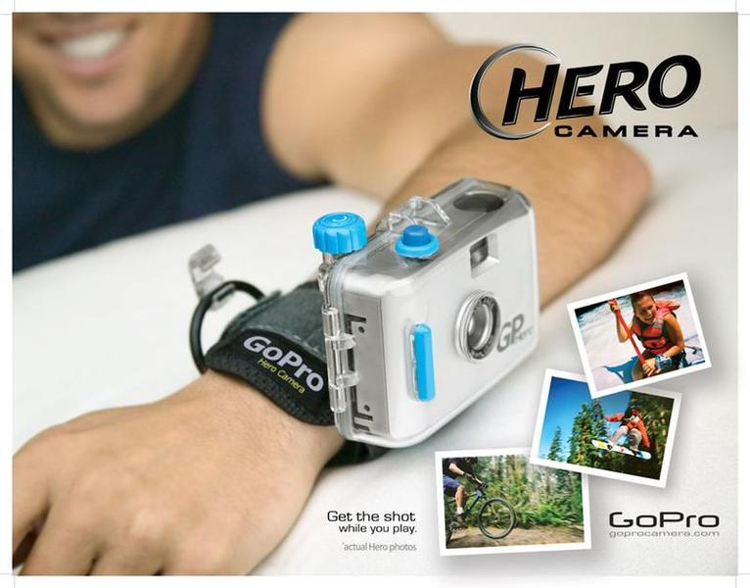
Every time one of us would get a sick barrel, we'd say to each other: "Agghh! If only we had a camera!" Every surfer knows that feeling! But for sure, I've got a couple of photos from early prototypes that convinced me the concept of a "HERO" camera, a camera that helps you capture footage that makes you feel like a HERO, was a good idea.That is how we came up with the name for our camera. The memory that probably sticks out the most is when GoPro started to be successful enough to allow me to go racing. I strapped our Digital HERO wrist camera onto the roll bar of a race car. The footage was so good and the camera looked so appropriate on the roll bar that it just hit me like a ton of bricks. I thought immediately, "We've got to make it so you can mount this camera everywhere..." and that was when we transitioned from being simply a wrist camera company, to the world leader in wearable and gear mountable cameras. I guess I can thank that race car for the idea.
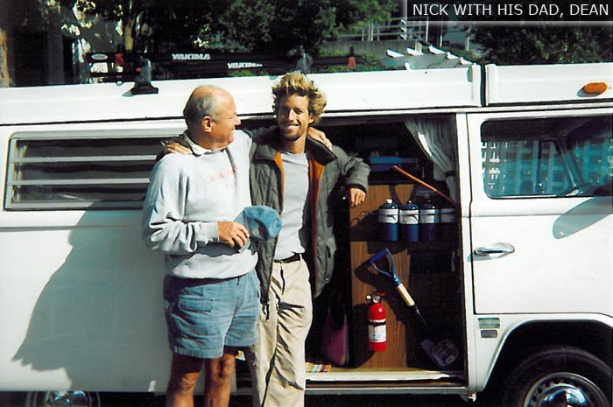
We earned money to start our business by selling Bead and shell belts. No jokes! After Australia, I flew to Indonesia to surf Bali, the Mentawais, Sumatra and West Java, traveling with Jill, my girlfriend, who was always pushing us further than I'd have gone alone. Every surfer should be so lucky to have a woman more hardcore than he is! One day Jill comes back to our place in Bali wearing this insanely cool bead and shell belt. Hardcore can be fashionable, too, apparently. Knowing prices in Bali, I asked how much, or how little, she paid for it. After my jaw hit the floor, we paid a visit to the belt maker, ordered 600 more and 2 months later the belts were done and all my boards were broken. We left Bali for California where my '74 VW Westfalia awaited along with a mission to sell as many belts as we could in 2 months, before summer ended. We sold most of them and then I moved back into my parent's place with enough money to launch GoPro. I thought it'd take two months to roll out our first product; it took two years.
At first the only thing on the market was Disposable waterproof cameras, and you had to be willing to pull the rubber band wrist strap around your neck and paddle around with it like Flava Flav. It was horrible, and 9 times out of 10 you either missed the shot, whacked yourself in the head, ripped your hair out when it got pinched in the rubber band, or you’d lose the camera altogether. I thought I was inventing the most important innovation in surfing while sewing together the first prototype GoPro wrist straps with a sewing machine I’d borrowed from my mom.!
As our product evolved from the original concept we have had a few big technology jumps. The jump from a 35mm film camera to digital, 10 second digital videos was big! Then came the jump to the 3 megapixel camera that sported an SD card slot and sound. Quantum leap! Next came the 170 degree wide angle lens that really put us on the map. It was like having your own IMAX camera. The effect of that wide angle lens was unreal. That combined with the mounting system that allows the camera to be worn and mounted in all the ways GoPro is now famous for. Our most recent big step is of course the launch of our HD HERO camera, broadcast quality HD for everyday use. It still blows me away how good this camera is, and that's what makes working at GoPro so fun. We're all just a bunch of stoked groms, playing with our own products, just as stoked as everyone else. More stoked, maybe!
GoPro has gone ballistic, all of our vertical action sports markets are doing well. And thanks to our broadcast quality HD HERO camera, we're seeing the professional production companies in film and TV buying our cameras as well. Some of your favorite shows on Discovery Channel, National Geographic, Fuel.TV and even LucasFilm are using GoPro in their productions. GoPro is a ton of fun for this reason. Everyone, for one reason or another, wants to GoPro in their own way. We give many thanks for this.
Answer the questions below and underline where the answer is found in the reading.
- Who is the founder of GoPro and how much is he worth?

- What sport inspired the GoPro?

- How did the company name of GoPro cpme about?

- How did the camera name Hero come about?

- How did Nick Woodman get the money to start GoPro?

- Name some production companies that use GoPro equipment?
*Find 20 pictures that were taken using GoPro equipment and save them into a folder and make a contact sheet of them.

