Assignment: The students will use Digital Images that scan, shoot or have shot and make a Brown Tone (Sepia), Selected Brown Tone, and Colored digital print. The Rules of Composition are demonstrated in the pictures they take and/or select. The Brown Tone, Selected Tone and Colored processes will be learned using Photoshop. The students will each turn in 3 digital prints [4” x 6” 300 resolution], one for Brown Tone, Selected Tone, and Colored process. The student’s work will be turned in via the teacher’s folder on the S:\ Drive in the following manner:
S:\Communications\Photography\4000 - Photo I\Student Drop\Teacher\Assignment folder.
Purpose: The Brown Tone, Selected Tone and Colored processes using Photoshop will be learned and the Rules of Composition will be practiced. The students will show mastery by turning in one photo for each, Brown Tone, Selected Tone, and Color print. The students will show mastery of the sepia process that will teach the students how to make old time Photographs. The colored process will also be mastered.
VAPA Content Standards Met:
1.1 Identify and use the principles of design to discuss, analyze, and write about visual aspects in the environment and in works of art, including their own.
1.2 Describe the principles of design as used in works of art, focusing on dominance and subordination.
1.4 Analyze and describe how the composition of a work of art is affected by the use of a particular principle of design.
1.5 Analyze the material used by a given artist and describe how its use influences the meaning of the work.
1.6 Compare and contrast similar styles of works of art done in electronic media with those done with materials traditionally used in the visual arts.
2.1 Solve a visual arts problem that involves the effective use of the elements of art and the principles of design.
2.2 Prepare a portfolio of original two-and three-dimensional works of art that reflects refined craftsmanship and technical skills.
2.3 Develop and refine skill in the manipulation of digital imagery (either still or video).
2.5 Create an expressive composition, focusing on dominance and subordination.
3.2 Identify and describe the role and influence of new technologies on contemporary works of art.
4.3 Formulate and support a position regarding the aesthetic value of a specific work of art and change or defend that position after considering the views of others.
4.4 Articulate the process and rationale for refining and reworking one of their own works of art.
4.5 Employ the conventions of art criticism in writing and speaking about works of art.

Grading: Rate your pictures from 1 to 6 in each of the following categories.
ALL items marked with ► must be graded 3 or higher to pass the assignment. Any ► item marked 0, 1, or 2 must be fixed to a 3 to pass assignment.
► = ES&C | Lowest -------- Highest |  |  |  |  | EC
► File Name | 1 | 2 | 3 | 4 | 5 | 6 | All files renamed properly.
► File Type | 1 | 2 | 3 | 4 | 5 | 6 | Converted to JPEG format.
► Size | 1 | 2 | 3 | 4 | 5 | 6 | Size of images are correct (4” W x 6” H or 6” W x 4” H)
► Resolution | 1 | 2 | 3 | 4 | 5 | 6 | Resolution is 300
► Uploaded | 1 | 2 | 3 | 4 | 5 | 6 | Files uploaded correctly.
Contrast | 1 | 2 | 3 | 4 | 5 | 6 | Contrast has been adjusted.
Creative | 1 | 2 | 3 | 4 | 5 | 6 | Photos are interesting and creative.  Different Photo’s used.
► Composition & Design | 1 | 2 | 3 | 4 | 5 | 6 | One or more Rules of Composition & Design used.
► Brown Toned | 1 | 2 | 3 | 4 | 5 | 6 | Brown tone process mastered and used in a creative manner. Rule demonstrated?
► Selected  Brown | 1 | 2 | 3 | 4 | 5 | 6 | Selected Brown tone process mastered and used in a creative manner.“Erased” properly.Rule demonstrated?
► Colored Print Sepia | 1 | 2 | 3 | 4 | 5 | 6 | Colored Print process mastered and used in a creative manner. Color added properly. Rule demonstrated?
► Colored Print BW | 1 | 2 | 3 | 4 | 5 | 6 | Colored Print process mastered and used in a creative manner. Color added properly. Rule demonstrated?
PhotoShop Skills | 1 | 2 | 3 | 4 | 5 | 6 | Demonstrates knowledge of Photoshop tools and techniques.
Questions | 1 | 2 | 3 | 4 | 5 | 6 | Questions on back answered.
Rubric | 1 | 2 | 3 | 4 | 5 | 6 | Self scored.
Meets Deadline | 1 | 2 | 3 | 4 | 5 | 6 | Meets assignment deadline.
Assignment | 1 | 2 | 3 | 4 | 5 | 6 | Meets assignment criteria
 |  |  |  |  |  |  | /85Total
Answer the following questions. You do not need to use complete sentences, but your responses must be understandable and legible.

- How can a Selective Brown Toned Photograph demonstrate dominance?
(The importance or the emphasis of one aspect in relation to all other aspects of a design.)

- Where did the idea of a brown tone picture come from?

- Which Rule of Composition do all 3 of the following Photographs demonstrate?
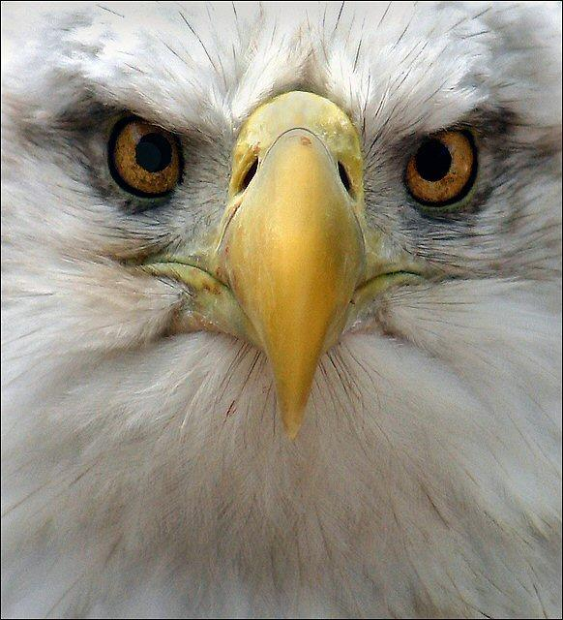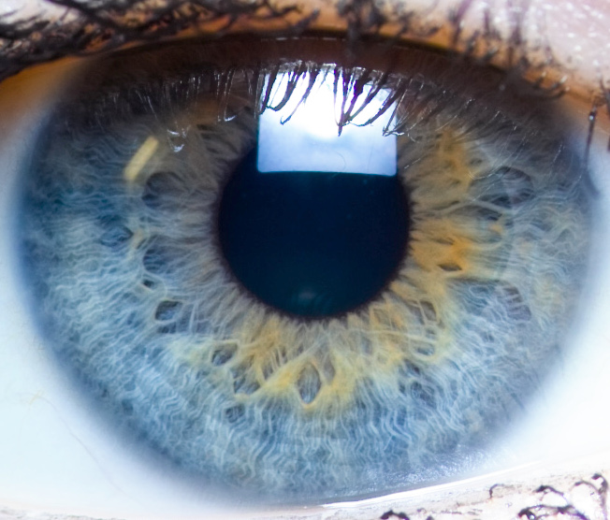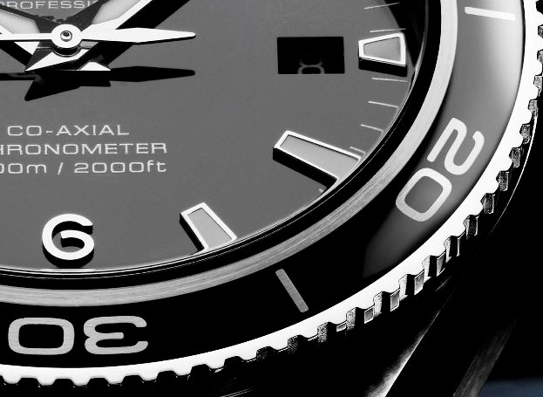

- How can an Action tool, like Sepia or Molten Lead, speed up the photographic process?

- Define these terms:
  - Color Theory

  - Intensity

  - Hue

  - Value

