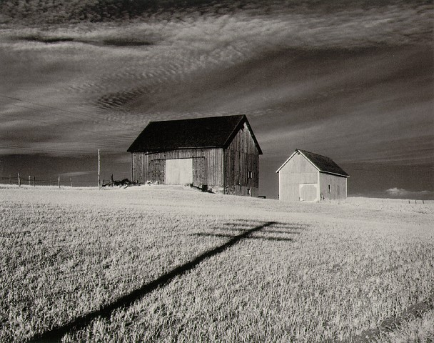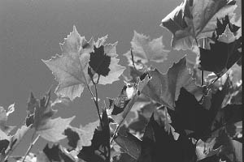Assignment: The student with will choose (with teacher) a negative to print from all of the shots that they have taken this year. With that negative the students will use it to make a print. The student will work with the teacher to turn in 1 - 4” x 5” critique print.

Purpose: The student will show mastery of using the enlarger, turning in 1 - 4” x 5” print. The Photo printing process will continue to be used and mastered as they do the assignment.

VAPA Content Standards Met:
1.1 Identify and use the principles of design to discuss, analyze, and write about visual aspects in the environment and in works of art, including their own.
1.2 Describe the principles of design as used in works of art, focusing on dominance and subordination.
Short Description of Picture Printed:
1.4 Analyze and describe how the composition of a work of art is affected by the use of a particular principle of design.
2.1 Solve a visual arts problem that involves the effective use of the elements of art and the principles of design.
2.2 Prepare a portfolio of original two-and three-dimensional works of art that reflects refined craftsmanship and technical skills.
2.5 Create an expressive composition, focusing on dominance and subordination.
4.4 Articulate the process and rationale for refining and reworking one of their own works of art.
4.5 Employ the conventions of art criticism in writing and speaking about works of art.

Grading: Rate your pictures from 1 to 6 in each of the following categories.
ALL items marked with ► must be graded 3 or higher to pass the assignment. Any ► item marked 0, 1, or 2 must be fixed to a 3 to pass assignment.
► = ES&C | Lowest ---------- Highest |  |  |  |  | EC |  |  | Teacher Initials
► Negative | 1 | 2 | 3 | 4 | 5 | 6 | Negative to be printed will be selected with the aid of the teacher.
► Cropping | 1 | 2 | 3 | 4 | 5 | 6 | Photo is cropped correctly.  Does it enhance one of the Rules of Composition & Design?
► Test Strip | 1 | 2 | 3 | 4 | 5 | 6 | Test Strip is cleared with teacher. Student works with teacher on making print.
► Print  Contrast | 1 | 2 | 3 | 4 | 5 | 6 | Difference between tones.  Black to white and middle gray.
► Technical | 1 | 2 | 3 | 4 | 5 | 6 | Free from dust, scratches and chemical marks. Use of the camera, enlarger, and chemicals shown.
► Composition & Design | 1 | 2 | 3 | 4 | 5 | 6 | Which of the Rules of Composition & Design does your picture demonstrate?  Answer:
► Matte | 1 | 2 | 3 | 4 | 5 | 6 | Matting enhances pictures. Pictures are trimmed, cut square, no glue on pictures, placement on paper, etc.
► Matte Labels | 1 | 2 | 3 | 4 | 5 | 6 | Presentation enhances pictures. Labeled; Header/Footer
Creative | 1 | 2 | 3 | 4 | 5 | 6 | Photo is interesting and creative.
Finished print is Scanned | 1 | 2 | 3 | 4 | 5 | 6 | Picture scanned; File named LN_FN_Critique; Saved as JPEG;  Saved to S:\ drive
Questions | 1 | 2 | 3 | 4 | 5 | 6 | Questions on back answered.
Rubric | 1 | 2 | 3 | 4 | 5 | 6 | Self Scored.
Meets Deadline | 1 | 2 | 3 | 4 | 5 | 6 | Meets deadline.
Assignment | 1 | 2 | 3 | 4 | 5 | 6 | Meets assignment criteria.  Finished Print checked by teacher.
 |  |  |  |  |  |  | /70 Total

Answer the following questions. You do not need to use complete sentences, but your responses must be understandable and legible.
- Why was this particular negative selected to be printed? [Quality & subject]

- How did the Test Strip help you print a better picture?

- Describe how filters are used when printing pictures in Traditional Photography.
  - Where is a filter placed?

  - What filter # did you use? Filter #: ____ and WHY? [relate to contrast]

- Define these terms (VAPA terms):
  - Aesthetics

  - Art Criticism

  - Reflection

