VAPA Content Standards Met:
2.1 Solve a visual arts problem that involves the effective use of the elements of art and the principles of design.
2.2 Prepare a portfolio of original two-and three-dimensional works of art that reflects refined craftsmanship and technical skills.
2.3 Develop and refine skill in the manipulation of digital imagery (either still or video).

PhotoShop – 4 Filters Assignment
In this assignment, you will be experimenting with a variety of filters can change a picture. You will place one picture in the top left corner of a canvas, copy it 3 times, and then adjust the 4 pictures with a different filter.

Setup Folder on network for project files:
- Create folders in your Photo1_[Last name]_2ndSem folder called: 4_Filters
  - Use Start > My Computer
  - Navigate to your Photo1_[Last name]_2ndSem
    - Create a folder called 4_Filters

LN = Last Name
FN = First Name
WC = Working copy
Creating the canvas:
- Select File > New
- Type in the name: LN_FN_4_Filters_#_WC
    - # = 1, 2, 3, 4, or 5
  - 4”W x 6”H or 6”W x 4”H inches
    - Depends on the picture’s orientation.
  - 300 resolution
  - RGB – color
  - Press OK
  - WC = Working Copy
    - This helps you protect your project incase you make a mistake.
  - You know have “canvas” to work on.
    - You can check if you set it up right if you select Image – Image size…
    - Your projects MUST be in the right size and resolution as directed or your prints will get messed up.

Pictures to use and setting up the project:
- Select 5 pictures.
  - You can be in the pictures if you want.
  - The pictures can be of friends, pets or objects.
  - The pictures CANNOT be from the internet.

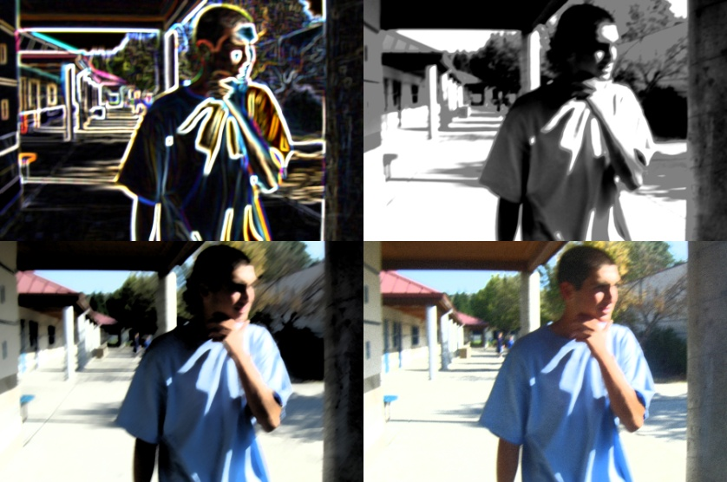
- You need to CROP each picture to place it in the canvas.
  - 6”W x 4”H Canvas
    - Crop picture to 3”W x 2”H
    - Copy and paste onto the canvas.
      - Close the original picture without saving the changes.
    - Drag the layer to the New Layer icon 3 times.
    - Arrange the pictures so that they are not overlapping.

  - 4”W x 6”H
    - Crop the picture to 2”W x 3”H
    - Copy and paste onto the canvas.
      - Close the original picture without saving the changes.
    - 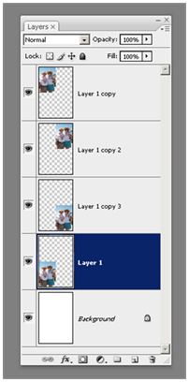Drag the layer to the New Layer icon 3 times.
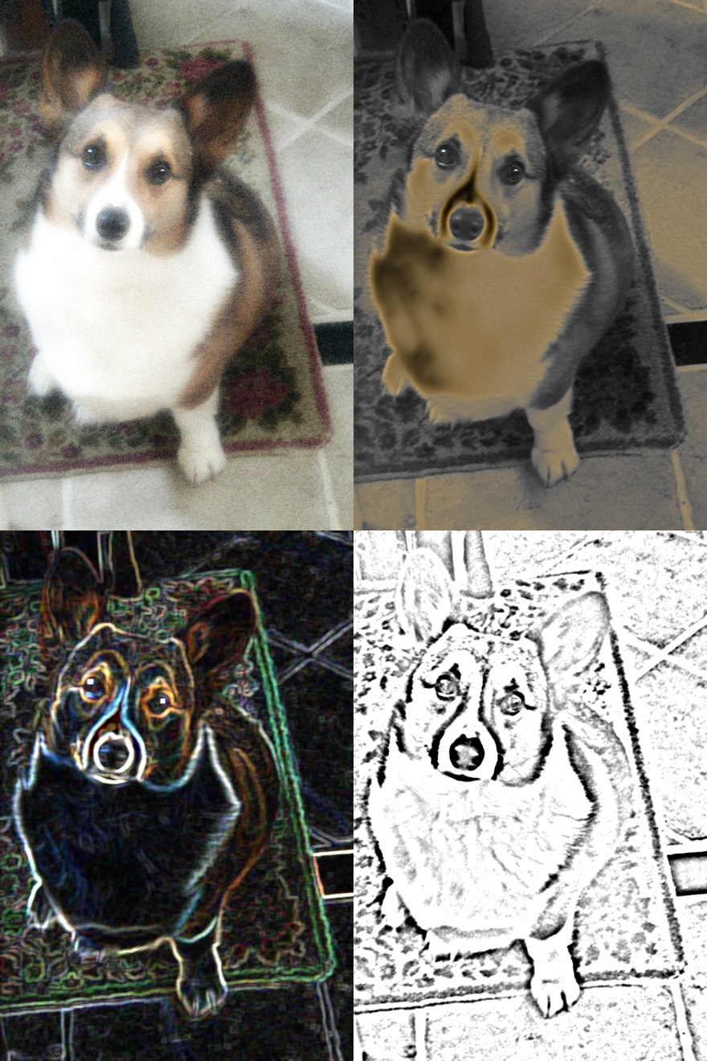
    - Arrange the pictures so that they are not overlapping.

Applying Filters:
- If you use Filter > Filter Gallery…you will see the various filters you can use in one place.
- Click on each layer and apply a filter to it.
  - Each layer must have a DIFFERENT filter applied to it.
  - Only apply ONE filter to each picture.
  - Make sure that the change is obvious.
  - NOTE: You will use a total of 20 different filters for this project.
- If you do NOT like a filter effect, be sure to use CTRL+Z to undo it right away. If you wait too long, you will not be able to undo the effect.

How to Save files:
- Select File – Save as…
- Navigate to H:\DOCS\Photo1_[LN]_2ndSem\4_Filters folder
- Format: Make sure it is a PSD [PhotoShop doc]
  - You will turn in as a JPEG later.
  - Save PhotoShop files as PSD documents, NOT as a JPEG or you will lose your layers.
    - You will save them as a JPEG for turning in. There is a special procedure for doing this.
- Press the Save button.

How to Save Text Styles assignment as a JPEG
LN = Last Name
FN = First Name
WC = Working Copy
orig = original
- First, save your project as a PSD
  - You should just have to press CTRL+S
  - LN_FN_4_Filters_#_WC
    - WC = working copy
- Next, File > Save as…
  - Save to your H:\Docs\Photo1_[last name]\4_Filters folder.
  - File name: Change WC to Final
    - LN_FN_4_Filters_#_Final
    - i.e. Morris_Richard_4_Filters_1_Final
  - Format: Change to JPEG
    - If it asks you to save layers, say NO
    - JPEG options dialog box
      - Image Options – Quality:
        - Choose 12 Maximum
      - Press OK

How to turn in the Text_Styles assignment
- Save the JPEG to the appropriate folder on the S:\ Drive.
  - Using My Computer:
    - Hold down the CTRL key and Left click on your 5 JPEG final files in your 4_Filters folder.
      - Right click on one of the highlighted pictures and choose Copy.
    - Navigate to the proper folder on the S:\ drive
S:\Communications\Photography\4000 - Photo I\Student Drop\[Teacher]_Classes
    - Right click on the right view and select Paste
    - NOTE: Please do not use drag and drop as this tends to “lock” the file and I cannot open it to grade. Also, do not use Save As… to save your file to the S:\ drive as this seems to cause the same problem.
- Fill out and turn in the Grading Rubric.

