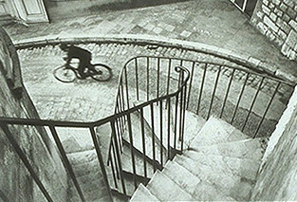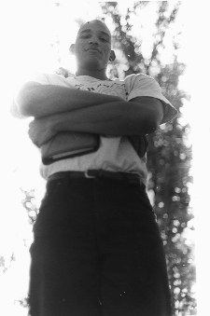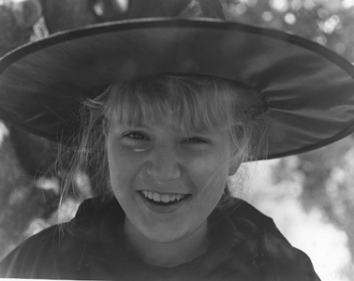

Assignment: The student will share a roll of film and shoot and develop it with the intent of capturing the 3 Views (High, Low, and Eye Level). The student will turn in 3-4” x 5” original prints, one for each of the 3 different Views. Rules of Composition & Design need to be observed to make the picture more creative.
Purpose: The students will learn the use of camera angles to enhance a subject. The use of the Rules of Composition & Design will be reviewed and used. The students will further show their mastery of the 3 Views by shooting and developing a roll of film with the intent of capturing each of the 3 Views in a original piece of work (picture). The students will show mastery by turning in one photo for each of the three views (Low, High, Eye). The Photo development and printing processes will continue to be used and mastered as they do the assignment.
VAPA Content Standards Met:
1.1 Identify and use the principles of design to discuss, analyze, and write about visual aspects in the environment and in works of art, including their own.
1.2 Describe the principles of design as used in works of art, focusing on dominance and subordination.
1.4 Analyze and describe how the composition of a work of art is affected by the use of a particular principle of design.
1.6 Compare and contrast similar styles of works of art done in electronic media with those done with materials traditionally used in the visual arts.
2.1 Solve a visual arts problem that involves the effective use of the elements of art and the principles of design.
2.2 Prepare a portfolio of original two-and three-dimensional works of art that reflects refined craftsmanship and technical skills.
2.3 Develop and refine skill in the manipulation of digital imagery (either still or video).
2.5 Create an expressive composition, focusing on dominance and subordination.
3.2 Identify and describe the role and influence of new technologies on contemporary works of art.
4.3 Formulate and support a position regarding the aesthetic value of a specific work of art and change or defend that position after considering the views of others.
4.5 Employ the conventions of art criticism in writing and speaking about works of art.
Grading Rubric: Rate your pictures from 1 to 6 in each of the following categories.
ALL items marked with ► must be graded 3 or higher to pass the assignment. Any ► item marked 0, 1, or 2 must be fixed to a 3 to pass assignment.
► = ES&C | Lowest -------------- Highest |  |  |  |  | EC
► Print Contrast | 1 | 2 | 3 | 4 | 5 | 6 | Difference between tones.  Black to White and middle Gray.
► Technical | 1 | 2 | 3 | 4 | 5 | 6 | Pictures free from dust, chemical marks, and scratches. Chemical process followed.
► Printing Skill | 1 | 2 | 3 | 4 | 5 | 6 | Printing shows a high level of Technique.
► Low Angle  [Camera looking up] | 1 | 2 | 3 | 4 | 5 | 6 | Picture taken from a Low angle.  Rule: | All pictures taken by the student who is turning in this grading sheet. This student CANNOT be in any of the pictures.
► Eye Level | 1 | 2 | 3 | 4 | 5 | 6 | Picture taken from Eye level.  Rule:
► High Angle  [Camera looking down] | 1 | 2 | 3 | 4 | 5 | 6 | Picture taken from a High angle.  Rule:
► Composition & Design | 1 | 2 | 3 | 4 | 5 | 6 | Rules of Composition & Design used to make the pictures more creative
Creativity | 1 | 2 | 3 | 4 | 5 | 6 | Overall creativity.
► Matte | 1 | 2 | 3 | 4 | 5 | 6 | Matting enhances pictures. Pictures are trimmed, Corners cut square, no glue on pictures, placement on paper, etc
► Matte Labels | 1 | 2 | 3 | 4 | 5 | 6 | Presentation enhances pictures. Labeled; Header/Footer
Questions | 1 | 2 | 3 | 4 | 5 | 6 | Questions on back answered.
Rubric | 1 | 2 | 3 | 4 | 5 | 6 | Self Scored.
Meets Deadline | 1 | 2 | 3 | 4 | 5 | 6 | Meets deadline.
Assignment | 1 | 2 | 3 | 4 | 5 | 6 | Meets assignment criteria.
 |  |  |  |  |  |  | /70 Total Score

Answer the following questions. You do not need to use complete sentences, but your responses must be understandable and legible.

- Which of the 3 views [High, Low or Eye Level] do you prefer and why?

- Pick one view and describe when you would use it.

  - View selected: ____________________

- What MOOD does a Low Angle shot convey?

- Define these terms:

